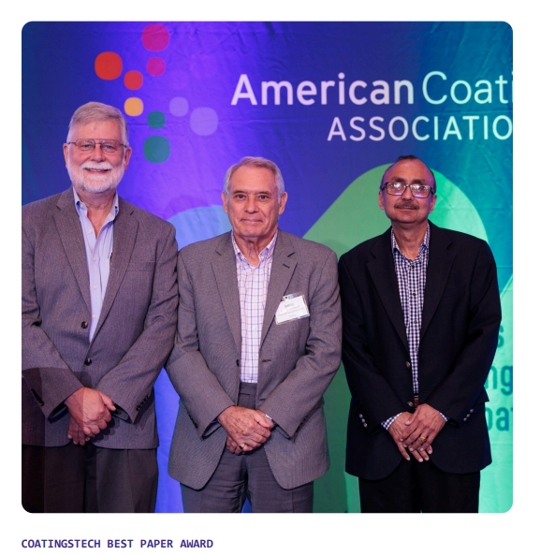

The CoatingsTech Best Paper Award recognizes the best overall paper contributed to the CoatingsTech Conference 2025.

It was presented to David Fairhurst, Ph.D., (center). He received the honor for his paper, “Low Field (LF)-NMR Relaxation – A Useful Technique for QC and to Determine the Equivalency of Materials for Coatings Formulations,” coauthored by Ravi Sharma, Ph.D., and principal research fellow at Mageleka Inc.; and Ralph Jan Wörheide, M.Eng., president and founder of Metromation Inc.

Fairhurst and his co-authors’ paper presents the application of Low Field Nuclear Magnetic Resonance (LF-NMR) relaxation as a powerful, fast, and non-destructive analytical tool for evaluating and routinely characterizing the performance of aqueous and non-aqueous dispersions of colored materials, particularly in the context of coatings formulations. Utilizing a small, benchtop LF-NMR spectrometer, the case studies presented emphasize how meaningful physicochemical information and insights can be obtained under real-use conditions, without the need for dilution, extensive sample preparation or destructive testing.